Chromatography Exam Questions

1. A student investigates the colours contained in inks from felt-tip pens. He uses chromatography and sets up his experiment as shown:
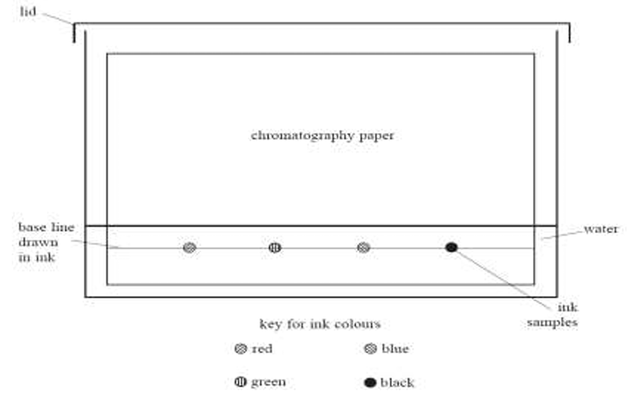

(a) Identify two mistakes in the way he sets up the experiment. For each mistake, state what problem it would cause.

1st mistake = ___________________________________________

Problem = ____________________________________________________________________

____________________________________________________________________

2nd mistake = ___________________________________________

Problem = ____________________________________________________________________

____________________________________________________________________

(b) Another student repeats the experiment, but does not make any mistakes. She uses inks from four different felt tip pens. The diagram shows her results.
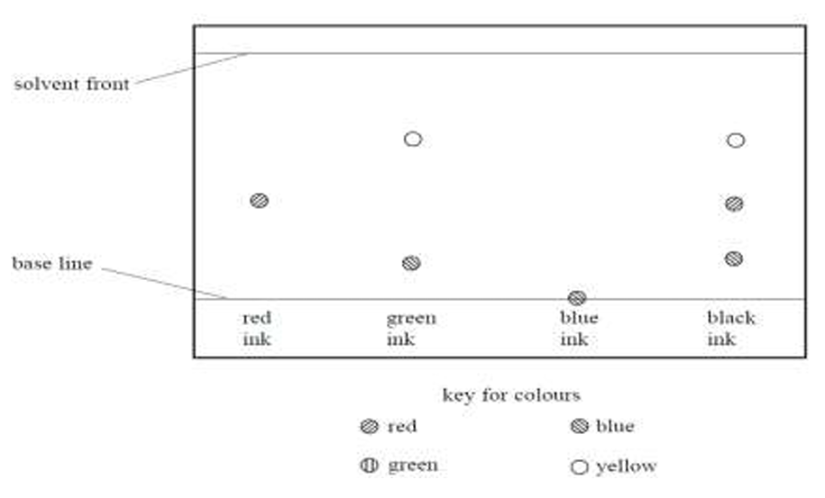
(c) (i) How many different colours does the black ink contain? ___________________

(ii) Which of the inks tested could be mixed together to make the black ink? ________________

(iii) Which of the inks tested is insoluble in water? Explain your answer. ___________________

____________________________________________________________________________

2. A student investigates the pigments found in some vegetables and fruit. She obtains some coloured vegetable and fruit extracts from carrots, tomatoes and sweet potatoes. She places a spot of each extract on chromatography paper, along with spots of the three pigments beta-carotene, chlorophyll and lycopene. Her teacher provides a solvent containing volatile, flammable, organic compounds for the experiment. The diagram shows the apparatus at the start of the experiment:

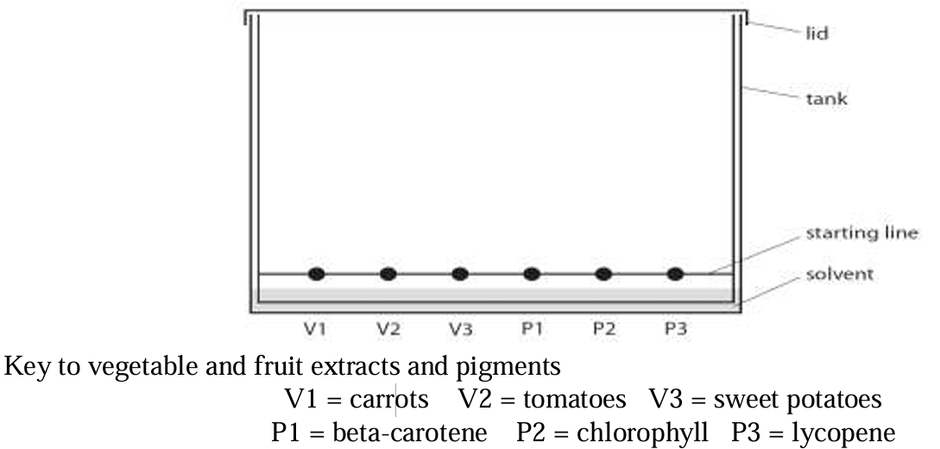

(a) Explain why it is important for the solvent level to be below the spots. ______________________

________________________________________________________________________________

(b) State two potential problems that are prevented by fitting the tank with a lid. _________________

________________________________________________________________________________

________________________________________________________________________________

The diagram shows the chromatogram at the end of the experiment.

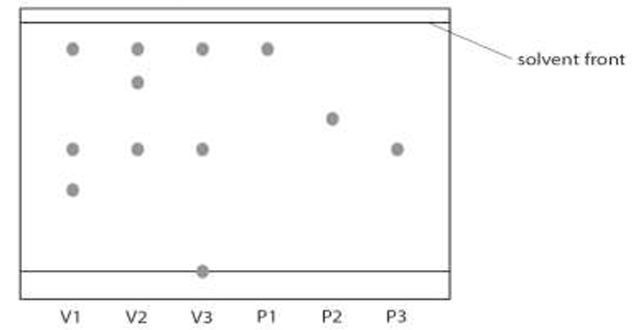

(c) Put a tick next to three statements that are supported by the chromatogram.
Chlorophyll is not present in carrots, sweet potatoes or tomatoes
Beta-carotene is present in carrots but not present in tomatoes.
Both beta-carotene and lycopene are present in sweet potatoes.
Lycopene is present in tomatoes but not present in carrots.
Both carrots and tomatoes contain a pigment other than beta-carotene, chlorophyll and lycopene.

(d) Suggest a reason why there is a spot on the starting line in the chromatogram for sweet potatoes.

__________________________________________________________________________________

